Group work assessment – declaration of contributions and accountabilities
Year | 2026
Semester | Second Semester
Unit Code | ENS6160
Unit Name | Signals and Systems
Assessment title | Laboratory 2
Group work – what is it?
The ability to effectively engage group (team) work is an essential skill that is built into the Unit and Course Learning Outcomes as well as assessment in many teaching units. Group work does not just entail multiple members of team working on distinct (separate) parts of an overall submission and then combining those individual parts into a single submission. Group work means a team collaborates over time on all aspects of a submission; they collectively construct and validate all parts of the work such that each member is knowledgeable, understands and can explain the various parts. Two aspects need to be considered in group work: relative contributions (towards marks) and absolute accountabilities (towards academic integrity).
Group work – relative contributions*
Group work contributions may be equally shared or differ between group members. In general, any group member contributing less than 10% to the overall submission should not be listed (will get a mark of zero). Where different group members have contributed (above 10% in a submission) but to varied extents, the table below can be used to acknowledge those contributions. If all have contributed equally, you can simply write “equally” against each name in the “Relative Contributions” column.
Group work – absolute accountabilities
All group members regardless of their relative contributions to a submission are accountable for the accuracy, completeness and (academic) integrity of the entire submission (not just specific aspects they may have contributed to). Should concerns relating to the (academic) integrity of a submission be identified and investigated, all group members are equally accountable. Signs to watch out for as potentially meaning some plagiarism, copying, collusion or cheating may have been involved in other group members work, when combining specific parts into an overall submission, include:
• group members that are not able to fully explain their contributions
• group members that do not continually engage the rest of the group in constructing the overall submission but they produce a (near complete) contribution at the end
• TurnItin reports that show similarity to parts of the submission, either arising out of copying, contract cheating or lack of paraphrasing.
• overly broad writing lacking in assessment context, or in a different style to previous work by the group member, and/or fabricated references which may indicate unacknowledged use of generative artificial intelligence tools
More information on academic integrity can be found here: https://intranet.ecu.edu.au/student/my-studies/academic-integrity

Relative contributions in completing this assessment
Student Name | Student Number | Relative Contribution*  (individual “%” or “equal”) | Signature
AMITHA SANTHOSH | 10734344 | EQUAL | 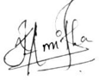
ANANDHU KAITHAVALAPPIL BINOD | 10730544 | EQUAL | 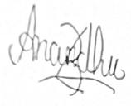



Edith Cowan University
School of Engineering
ENS6160 Signals and Systems
Laboratory Report 2
Frequency Response of Systems: Sinusoidal and Square-Wave Analysis of an RC Low-Pass Filter

Abstract
Linear time-invariant (LTI) systems are essential to analogue signal conditioning, anti-aliasing and smoothing PWM waveforms. A passive first order series RC circuit (R = 1.5 kΩ, C = 0.01 μF) was tested in this study to examine its frequency response characteristics when its output is measured across the capacitor, using sinusoidal and periodic square wave inputs. This was tested in the time and fast Fourier transform (FFT) domain on a Keysight DSOX4024G oscilloscope and confirmed as a low-pass filter with time constant τ = 15 µs and a −3 dB cut-off frequency fc = 10.61 kHz by performing a differential-equation analysis. Under 15 Vpp sinusoidal inputs at 1, 10, and 40 kHz, measured outputs (15.20, 11.50, and 4.22 Vpp; phase lags −6.65°, −42.30°, and −73.71°) and frequency-domain gains (−0.23, −2.81, and −11.35 dB) closely matched theoretical gains (−0.04, −2.76, and −11.82 dB). For an 8 kHz, 50% duty-cycle square wave, theoretical 15 Vpp odd harmonics at 8, 24, and 40 kHz attenuated to 7.63, 1.29, and 0.49 V (−1.95, −7.87, and −11.82 dB). Experimentally, an observed 20.1 Vpp input produced a smoothed exponential output of 14.9 Vpp, and the FFT confirmed the odd-harmonic peaks. Because the FFT cursor levels could not be read reliably, predicted Table C harmonic outputs of 20.19, 4.72, and −3.65 dBV were used to supplement the measurements, thereby verifying the principles of LTI filtering and Fourier superposition.
Table of Contents
Abstract 4
1. Introduction 8
2. Method 8
2.1 Equipment and Components 8
2.2 Circuit Configuration 8
2.3 Time-Domain Measurements 9
2.4 Frequency-Domain Analysis 10
2.5 Square-Wave Measurements 10
2.5.1 Square-Wave Circuit Configuration and Procedure 10
2.5.2 Governing Equations and Assumptions 11
3. Results 12
3.1 Frequency Response Derivation 12
3.1.1 Frequency Response Derivation (A(a)) 12
3.1.2 Theoretical Magnitude Response (Post-Lab A(b)) 12
3.1.3 Theoretical Amplitude and Phase Response (Post-Lab A(c)) 13
3.1.4 Filter Type (A(d)) 13
3.1.5 Cut-off Frequency (Post-Lab A(e)) 14
3.1.6 Frequency-Domain and Time-Domain Behaviour (Post-Lab A(f)) 14
3.2 Response of the RC Circuit to an AC Voltage (Post-Lab B) 15
3.2.1 Theoretical Output Voltage (Post-Lab B(a)) 15
3.2.2 Magnitude and Phase Spectra of Output Voltage (Post-Lab B(b)) 16
3.3 Experimental Frequency Response in the Time Domain 16
3.3.1 Comparison of Theoretical and Measured Results 17
3.3.2 Input–Output Waveforms 18
3.3.3 Filtering type and comparison of cut-off frequency (−3 dB point) between the measured and theoretical values 18
3.4 Experimental Frequency Response in the Frequency Domain 18
3.4.1 Frequency Response Magnitude for Sinusoidal Inputs 20
3.4.2 Comparison of measured results with theoretical (post-lab) values 20
3.4.3 Output Spectra and Comparison 21
3.5 Post-Lab Section C: Theoretical Calculations (15 V_{pp}, 8 kHz Square Wave) 21
3.6 Experimental Square-Wave Oscilloscope Measurements (Time Domain & FFT) 26
3.7 Result Sheet Section C: Predicted Harmonic Response for 20.1 V_{pp} Input (Table C) 27
4. Discussion 28
4.1 Sinusoidal Frequency Response 28
4.2 Low-Pass Filtering and Square-Wave Edge Smoothing 29
4.3 Input Voltage Discrepancy (15 V_{pp} vs. 20.1 V_{pp}) 29
4.4 Separation of Data Sets and Experimental Limitations 29
5. Conclusion 30
References 30
Appendix 31
Acknowledgement of AI Use 33

List of Figures
Figure 1. RC Low-Pass Filter Circuit Diagram 9
Figure 2. Physical RC Circuit Setup 9
Figure 3. RC low-pass filter circuit schematic and oscilloscope setup (R = 1.5 kΩ, C = 0.01 µF, 8 kHz square-wave excitation). 10
Figure 4. Theoretical amplitude of the RC low-pass filter (0–60 kHz) 13
Figure 5. Theoretical phase response of the RC low-pass filter (0–60 kHz). 14
Figure 6. Output voltage magnitude against frequency. 16
Figure 7. Output voltage phase against frequency. 16
Figure 8. Input and output voltage waveforms at 1 kHz, 10 kHz and 40 kHz. 18
Figure 9. Input and Output Voltage Magnitude Spectra at 1 kHz, 10 kHz and 40 kHz 21
Figure 10. Theoretical RC frequency response (0–60 kHz) showing cut-off f_{c} = 10.61 kHz and harmonic operating points at 8, 24, and 40 kHz: (a) linear magnitude, (b) decibel gain, and (c) phase. 23
Figure 11. Theoretical discrete input and output harmonic spectra for the 15 V_{pp}, 8 kHz square wave: (a) peak Volts, (b) peak-convention dBV, and (c) phase lag. 25
Figure 12. Scaled theoretical time-domain waveforms (15 V_{pp}, 8 kHz): (a) input square wave and 3-harmonic synthesis; (b) steady-state capacitor output (±7.27 V, 14.54 V_{pp}). 26
Figure 13. (a) Predicted harmonic magnitudes (20.1 V_{pp} basis) vs. 15 V_{pp} theoretical outputs; (b) harmonic gains along the RC Bode curve. 28
Figure A1. Experimental input and output sinusoidal waveforms at 1 kHz. 31
Figure A2. Experimental input and output sinusoidal waveforms at 10 kHz. 32
Figure A3. Experimental input and output sinusoidal waveforms at 40 kHz. 32
Figure A4. Experimental oscilloscope capture of the 8.00 kHz square wave: CH1 input = 20.1 Vpp (Ampl = 15.1 V) and smoothed CH2 output = 14.9 Vpp (Ampl = 14.2 V). 33
Figure A5. Experimental FFT(CH2) captures at (a) 8.0 kHz, (b) 23.9 kHz (~24 kHz), and (c) 40.0 kHz (manual Y1 cursor uncoupled at −2.50 dBV). 33

List of Tables
Table 1. Theoretical Magnitude Response of the RC Circuit 12
Table 2. Theoretical Output Voltage of the RC Circuit 15
Table 3. Theoretical and Measured Frequency Response of the RC Circuit 17
Table 4. Experimental and Theoretical Frequency Response Magnitudes 20
Table 5. Theoretical RC frequency response at DC, cut-off, and odd square-wave harmonics (R = 1.5 kΩ, C = 0.01 µF). 23
Table 6. Post-Lab Section C summary of theoretical input and output harmonics for the 15 V_{pp}, 8 kHz square wave (peak dBV convention). 24
Table 7. Experimental oscilloscope measurements for the 8 kHz square wave. 26
Table 8 (Table C). Predicted square-wave harmonic response for the observed 20.1 V_{pp} input (peak-amplitude dBV — predicted, not measured). 28

1. Introduction
Frequency response describes how a system responds to signals at different frequencies. For this experiment, the frequency response of a resistor-capacitor (RC) circuit was explored, both in the time and frequency domains. The circuit consisted of a 1.5 kΩ resistor and a 0.01 µF capacitor, with the output voltage measured across the capacitor. It operates as a low-pass filter, allowing low-frequency signals to pass with minimal attenuation while reducing higher-frequency signals.
The objective of this experiment was to establish the frequency response of RC circuit and to compare theoretical results and experimental results. The sinusoidal signals at 1 kHz, 10 kHz and 40 kHz were applied and the voltage and phase shift were measured with an oscilloscope. The amplitude and phase responses were also examined in the frequency range 0 - 60 kHz. In addition, the response of the circuit to a square-wave input was explored to see what effect the filter has on the different frequency components of the square wave.
A periodic square wave is made up of a fundamental sinusoid as well as odd harmonics (n = 1, 3, 5, …) each multiplied by a frequency response H(jnω0) (ECU, 2026c). So, the objective of the square-wave investigation was to calculate the Fourier coefficients and filtered output harmonics of an 8 kHz, 15 Vpp (50% duty-cycle) square wave, view the time domain and FFT response of the device on the oscilloscope, and compare the output harmonics with the calculated harmonics for the measured 20.1 Vpp input.

2. Method

2.1 Equipment and Components
The following equipment and components were used during the experiment:
- Resistor – 1.5 kΩ
- Capacitor – 0.01 µF
- Function generator
- Oscilloscope
- Breadboard and jumper wires

2.2 Circuit Configuration
The RC circuit was connected with the resistor in series with the input and the capacitor connected between the output and ground. The output voltage was measured across the capacitor. The function generator supplied the input signal, while the oscilloscope was used to observe the input and output waveforms.
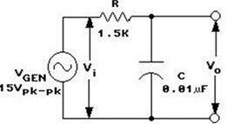
Figure 1. RC Low-Pass Filter Circuit Diagram
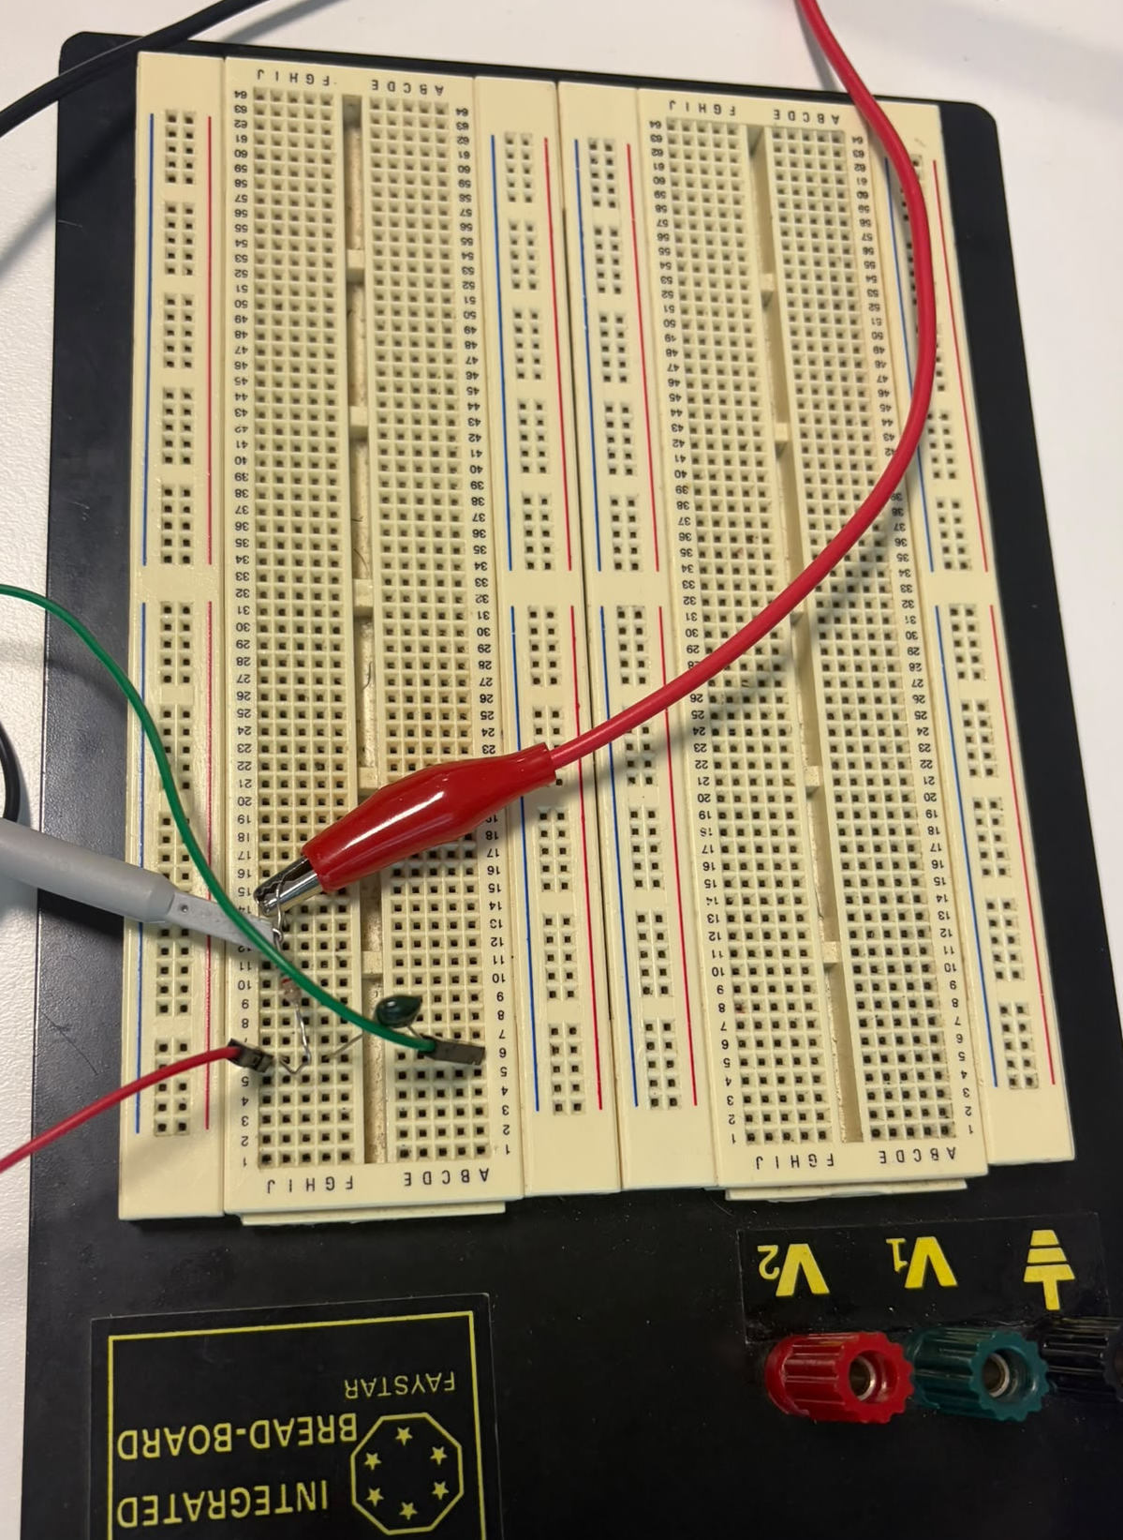
Figure 2. Physical RC Circuit Setup

2.3 Time-Domain Measurements
A sinusoidal input signal of approximately 15 Vpp was applied at frequencies of 1 kHz, 10 kHz and 40 kHz. The input and output waveforms were observed using the oscilloscope. At each frequency, the peak-to-peak voltages and phase differences were measured and recorded for comparison with theoretical values.

2.4 Frequency-Domain Analysis
The frequency response of the RC circuit was examined using sinusoidal input signals at 1 kHz, 10 kHz and 40 kHz. The input and output voltages were observed using the oscilloscope, and the measured values were used to calculate the magnitude response in decibels. These results were compared with the theoretical frequency response. The theoretical amplitude and phase responses were also plotted over a frequency range of 0–60 kHz using Python in Google Colab (Google, 2019).

2.5 Square-Wave Measurements
A square-wave signal was applied to the RC circuit using the function generator. The input and output waveforms were observed using the oscilloscope to examine the circuit's response. The changes in the output waveform were analysed to understand how the RC low-pass filter affects the frequency components of a square-wave signal. The experimental observations were then compared with the expected theoretical behaviour.

2.5.1 Square-Wave Circuit Configuration and Procedure
The resistor (R = 1.5 kΩ) was placed in series with the input source vi(t) and the capacitor (C = 0.01 µF) was placed across the output node vo(t) and ground (Figure 3). At 50 μs/div, the oscilloscope recorded the peak-to-peak voltage, the plateau amplitude, and the frequency in Channel 1 (10 V/div) and Channel 2 (5 V/div), for the voltage vi(t) and vo(t), respectively. The odd peaks close to 8, 24 and 40 kHz were checked using hardware Math FFT.
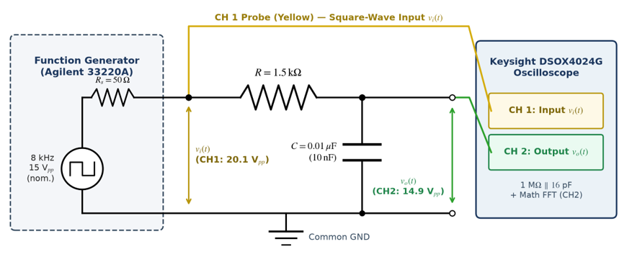
Figure 3. RC low-pass filter circuit schematic and oscilloscope setup (R = 1.5 kΩ, C = 0.01 µF, 8 kHz square-wave excitation).

2.5.2 Governing Equations and Assumptions
Step 1 – Circuit differential equation: Applying Kirchhoff’s voltage law with capacitor current i(t) = C dv_{o}(t)/dt gives the circuit differential equation (ECU, 2026a):
$$RC\frac{\text{d}v_{o}\left(t\right)}{\text{d}t} + v_{o}\left(t\right) = v_{i}\left(t\right)$$ | (1)
Step 2 – Frequency response: Substituting v_{i}(t) = e^{jωt} and v_{o}(t) = H(jω)e^{jωt} yields the transfer function, magnitude, decibel gain, and phase:
Transfer function: $H\left(jω\right) = \frac{\text{1}}{\text{1} + jωRC}$  Magnitude: $\left|H\left(jω\right)\right| = \frac{\text{1}}{\sqrt{\text{1} + {\left(ωRC\right)}^{\text{2}}}}$  Phase: $∠H\left(jω\right) = -{\text{tan}}^{\text{-1}}\left(ωRC\right)$ | (2)
Step 3 – Time constant and cut-off frequency: Time constant τ and −3 dB cut-off frequency (where |H(jω_{c})| = 1/√2 = 0.7071):
Time constant: $τ = RC = \left(\text{1500}\right)\left(\text{0.01 × }{\text{10}}^{\text{-6}}\right)\text{ = 15 µs}$  Cut-off frequency: $f_{c} = \frac{\text{1}}{2πRC} = \frac{\text{1}}{2π\left(\text{1500}\right)\left(\text{0.01 × }{\text{10}}^{\text{-6}}\right)}\text{ = 10.61 kHz}$ | (3)
Step 4 – Fourier series of the square-wave input: For a zero-mean, 50% duty-cycle odd square wave of peak amplitude A = V_{pp}/2 and fundamental ω₀ = 2πf₀, a₀ = 0, a_{n} = 0, and b_{n} = 0 for even n. Only odd harmonics (n = 1, 3, 5, …) are non-zero:
Fourier series: $v_{i}\left(t\right) = ∑_{n=1,3,5,…} b_{n}\text{ sin}\left(nω_{\text{0}}t\right)$  Coefficients: $b_{n} = \frac{4A}{nπ}$ | (4)
Step 5 – Filtered output and time-domain response: Filtered harmonic output magnitude, peak-convention dBV level, decibel gain, and steady-state peak capacitor voltage:
Output magnitude: $\left|V_{o,n}\right| = b_{n}\left|H\left(jnω_{\text{0}}\right)\right|$  dBV level: $L_{\text{dBV}}\text{ = 20 }{\text{log}}_{\text{10}}\left(V_{\text{peak}}\right)$  Gain: $G_{n} = V_{\text{o,n(dBV)}} - b_{\text{n(dBV)}}$  Peak output: $V_{\text{o,peak}} = A tanh\left(\frac{T_{\text{0}}}{4RC}\right)$ | (5)
• Assumptions: Nominal R = 1.5 kΩ and C = 0.01 µF are used with negligible 1 MΩ ∥ 16 pF probe loading (<0.01% shift in fc). Note that for Post-Lab Section C, the specified 15 Vpp input is used, while for Table C, analytical predictions for the observed 20.1 Vpp input is used because paired input–output peak cursor readings were not saved in the FFT captures.

3. Results

3.1 Frequency Response Derivation

3.1.1 Frequency Response Derivation (A(a))
The RC circuit is described by the linear constant-coefficient differential equation (LCCDE):
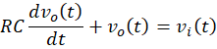
Taking the Fourier transform of both sides:
Therefore, the frequency response is:
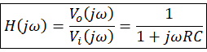
Where

3.1.2 Theoretical Magnitude Response (Post-Lab A(b))
The magnitude ratio of the RC circuit is given by:
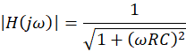

Table 1. Theoretical Magnitude Response of the RC Circuit
Frequency, | Angular Frequency, (rad/s) | Magnitude Ratio, | Gain,
1 kHz | 6,283.19 | 0.9956 | −0.04
10 kHz | 62,831.85 | 0.7277 | −2.76
40 kHz | 251,327.41 | 0.2564 | −11.82

3.1.3 Theoretical Amplitude and Phase Response (Post-Lab A(c))
The theoretical amplitude and phase responses of the RC circuit were plotted over a frequency range of 0–60 kHz using Python in Google Colab (Google, 2019).

3.1.4 Filter Type (A(d))
The RC circuit operates as a low-pass filter, allowing low-frequency signals to pass with minimal attenuation while reducing the amplitude of higher-frequency signals.
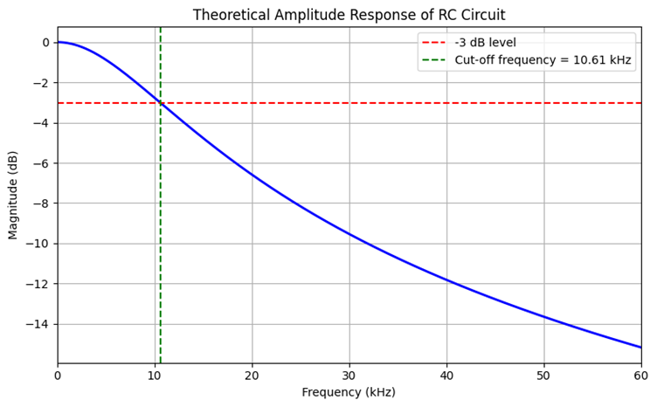
Figure 4. Theoretical amplitude of the RC low-pass filter (0–60 kHz)
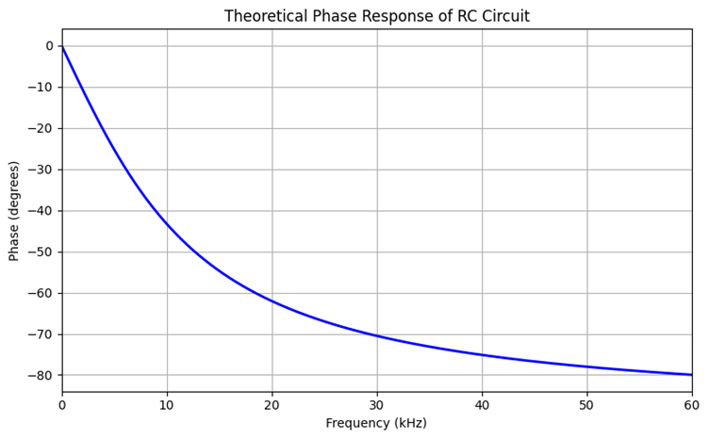
Figure 5. Theoretical phase response of the RC low-pass filter (0–60 kHz).

3.1.5 Cut-off Frequency (Post-Lab A(e))
The −3 dB point corresponds to a voltage amplitude ratio of:
The cut-off frequency of the RC circuit is calculated using:
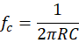
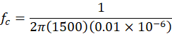
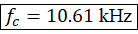

3.1.6 Frequency-Domain and Time-Domain Behaviour (Post-Lab A(f))
Frequency Domain: The RC low-pass filter enables the passage of low frequency signals with little attenuation. With higher frequencies, the amplitude of the output decreases and the phase shift becomes more negative.
Time Domain: The output voltage follows slowly varying input signals more closely, while rapid changes in the input are smoothed due to the charging and discharging behaviour of the capacitor.

3.2 Response of the RC Circuit to an AC Voltage (Post-Lab B)

3.2.1 Theoretical Output Voltage (Post-Lab B(a))
A sinusoidal input voltage of 15 Vpp with a phase angle of 0° was considered at frequencies of 1 kHz, 10 kHz and 40 kHz.
The input peak amplitude is:
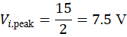

Table 2. Theoretical Output Voltage of the RC Circuit
Frequency | (rad/s) | ) |  | (V peak)
1 kHz | 6,283.19 | 0.9956 | −5.39° | 7.467 | −5.39°
10 kHz | 62,831.85 | 0.7277 | −43.30° | 5.458 | −43.30°
40 kHz | 251,327.41 | 0.2564 | −75.14° | 1.923 | −75.14°

3.2.2 Magnitude and Phase Spectra of Output Voltage (Post-Lab B(b))
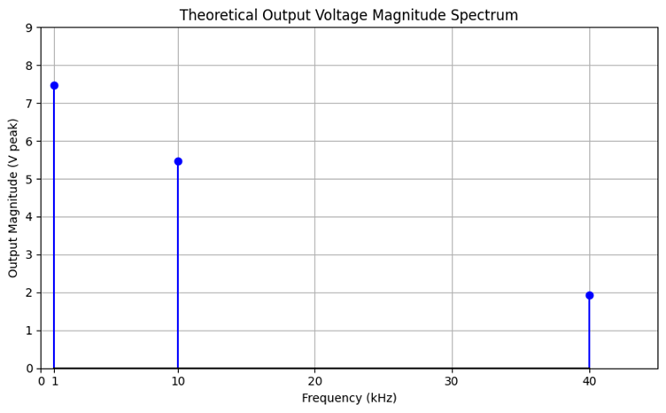
Figure 6. Output voltage magnitude against frequency.
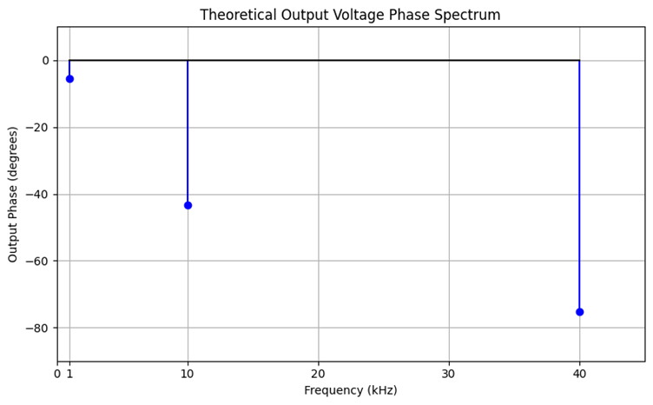
Figure 7. Output voltage phase against frequency.

3.3 Experimental Frequency Response in the Time Domain
At :
At :
At :

3.3.1 Comparison of Theoretical and Measured Results
Table 3. Theoretical and Measured Frequency Response of the RC Circuit
Frequency | Magnitude |  | Phase
Frequency | Theoretical Value | Measured Value | Theoretical Value | Measured Value
1kHz | 14.93 | 15.20 | -5.39 | -6.65
10kHz | 10.92 | 11.50 | -43.3 | -42.30
40kHz | 3.85 | 4.22 | -75.1 | -73.71

3.3.2 Input–Output Waveforms
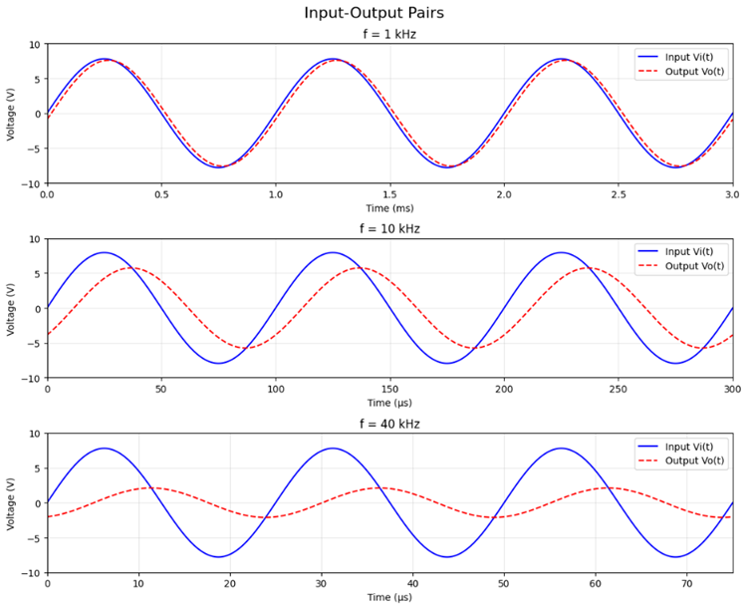
Figure 8. Input and output voltage waveforms at 1 kHz, 10 kHz and 40 kHz.

3.3.3 Filtering type and comparison of cut-off frequency (−3 dB point) between the measured and theoretical values
The RC circuit acts as a low-pass filter, as the output magnitude decreases with increasing frequency.
The theoretical cut-off frequency is:
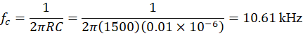
The measured gain at 10 kHz was −2.81 dB, which is close to the theoretical −3 dB cut-off point. This indicates good agreement between the theoretical and experimental frequency responses.

3.4 Experimental Frequency Response in the Frequency Domain
The theoretical magnitude response was calculated using:
At :
At :
At :
The voltage magnitude in dBV was calculated using:
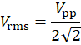
The measured gain was calculated using:
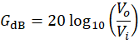
At :
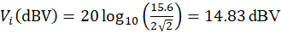 , 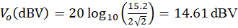
At :

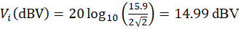 , 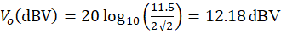
At :

, 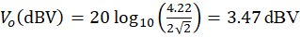

3.4.1 Frequency Response Magnitude for Sinusoidal Inputs
Table 4. Experimental and Theoretical Frequency Response Magnitudes
Frequency | Output Magnitude | Input Magnitude | Magnitude Gain | Theoretical Response
1kHz | 14.61 | 14.83dBV | -0.23dB | -0.0384dB
10kHz | 12.18dBV | 14.99dBV | -2.81dB | -2.7606dB
40kHz | 3.47dBV | 14.83dBV | -11.35dB | -11.821dB

3.4.2 Comparison of measured results with theoretical (post-lab) values
The measured gains showed good agreement with the theoretical values, particularly at 10 kHz, where the difference was only 0.05 dB. A slightly larger difference of 0.47 dB was observed at 40 kHz, while the difference at 1 kHz was approximately 0.19 dB. Overall, the results followed the expected low-pass frequency response, with greater attenuation at higher frequencies.

3.4.3 Output Spectra and Comparison
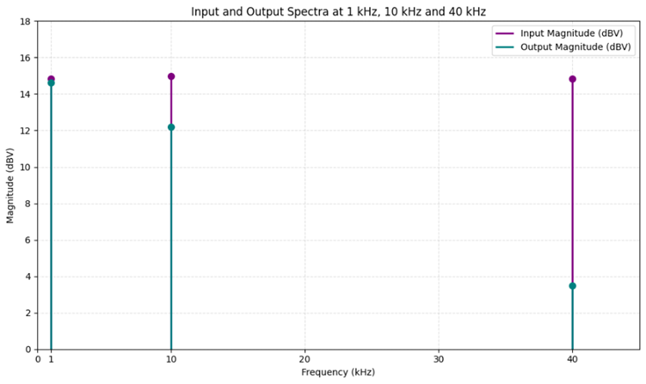
Figure 9. Input and Output Voltage Magnitude Spectra at 1 kHz, 10 kHz and 40 kHz
The result is that there was virtually no attenuation between input and output at 1 kHz. The output level was slightly reduced at 10 kHz and considerably reduced at 40 kHz with the output level reading 3.47 dBV. This verifies that the RC circuit is low-pass, meaning that the higher frequencies are suppressed more.

3.5 Post-Lab Section C: Theoretical Calculations (15 V_{pp}, 8 kHz Square Wave)
C(a) Fourier Series Coefficients of the Input Square Wave
Given: V_{pp} = 15 V, f₀ = 8000 Hz, 50% duty cycle
Step 1 – Peak amplitude: A = V_{pp}/2 = 15/2 = 7.50 V
Step 2 – Angular frequency and period: ω₀ = 2π(8000) = 50,265.48 rad/s; T₀ = 1/f₀ = 125 µs
Step 3 – Coefficient formula (Equation 4; ECU, 2026d): b_{n} = 4A/(nπ) = 4(7.50)/(nπ) = 30/(nπ) V for odd n; b_{n} = 0 for even n
Step 4 – Evaluate each odd harmonic:
n = 1 (f₁ = 8 kHz)
Coefficient: $b_{\text{1}} = \frac{\text{30}}{1π}\text{ = 9.55 V}$
Level: $b_{\text{1(dBV)}}\text{ = 20 }{\text{log}}_{\text{10}}\left(\text{9.55}\right)\text{ = 19.60 }\text{dBV}$
n = 3 (f₃ = 24 kHz)
Coefficient: $b_{\text{3}} = \frac{\text{30}}{3π}\text{ = 3.18 V}$
Level: $b_{\text{3(dBV)}}\text{ = 20 }{\text{log}}_{\text{10}}\left(\text{3.18}\right)\text{ = 10.06 }\text{dBV}$
n = 5 (f₅ = 40 kHz)
Coefficient: $b_{\text{5}} = \frac{\text{30}}{5π}\text{ = 1.91 V}$
Level: $b_{\text{5(dBV)}}\text{ = 20 }{\text{log}}_{\text{10}}\left(\text{1.91}\right)\text{ = 5.62 }\text{dBV}$
C(b) Magnitude and Phase of RC Frequency Response at Harmonic Frequencies
Given: RC = (1500)(0.01 × 10⁻⁶) = 1.5 × 10⁻⁵ s
Method (Equation 2), for each harmonic: (1) ω = 2πf and ωRC; (2) |H(jω)| = 1/√(1 + (ωRC)²); (3) G = 20 log₁₀|H(jω)|; (4) ∠H(jω) = −tan⁻¹(ωRC)
At f₁ = 8 kHz (ω₁ = 50,265.48 rad/s, ω₁RC = 0.7540):
Magnitude: $\left|H\left(jω_{\text{1}}\right)\right| = \frac{\text{1}}{\sqrt{\text{1 + }{\text{0.7540}}^{\text{2}}}}\text{ = 0.7985}$
Gain: $G_{\text{1}}\text{ = 20 }{\text{log}}_{\text{10}}\left(\text{0.7985}\right)\text{ = -1.95 dB}$
Phase: $\text{∠}H\left(jω_{\text{1}}\right) = -{\text{tan}}^{\text{-1}}\left(\text{0.7540}\right)\text{ = -37.02°}$
At f₃ = 24 kHz (ω₃ = 150,796.45 rad/s, ω₃RC = 2.2619):
Magnitude: $\left|H\left(jω_{\text{3}}\right)\right| = \frac{\text{1}}{\sqrt{\text{1 + }{\text{2.2619}}^{\text{2}}}}\text{ = 0.4043}$
Gain: $G_{\text{3}}\text{ = 20 }{\text{log}}_{\text{10}}\left(\text{0.4043}\right)\text{ = -7.87 dB}$
Phase: $\text{∠}H\left(jω_{\text{3}}\right) = -{\text{tan}}^{\text{-1}}\left(\text{2.2619}\right)\text{ = -66.15°}$
At f₅ = 40 kHz (ω₅ = 251,327.41 rad/s, ω₅RC = 3.7699):
Magnitude: $\left|H\left(jω_{\text{5}}\right)\right| = \frac{\text{1}}{\sqrt{\text{1 + }{\text{3.7699}}^{\text{2}}}}\text{ = 0.2564}$
Gain: $G_{\text{5}}\text{ = 20 }{\text{log}}_{\text{10}}\left(\text{0.2564}\right)\text{ = -11.82 dB}$
Phase: $\text{∠}H\left(jω_{\text{5}}\right) = -{\text{tan}}^{\text{-1}}\left(\text{3.7699}\right)\text{ = -75.14°}$
Table 5. Theoretical RC frequency response at DC, cut-off, and odd square-wave harmonics (R = 1.5 kΩ, C = 0.01 µF).
Spectral Point | Frequency (kHz) | ω (rad/s) | Magnitude | Gain (dB) | Phase (°)
DC | 0.00 | 0.00 | 1.0000 | 0.00 | 0.00
Fundamental | 8.00 | 50,265.48 | 0.7985 | −1.95 | −37.02
Cut-off | 10.61 | 66,666.67 | 0.7071 | −3.01 | −45.00
3rd Harmonic | 24.00 | 150,796.45 | 0.4043 | −7.87 | −66.15
5th Harmonic | 40.00 | 251,327.41 | 0.2564 | −11.82 | −75.14
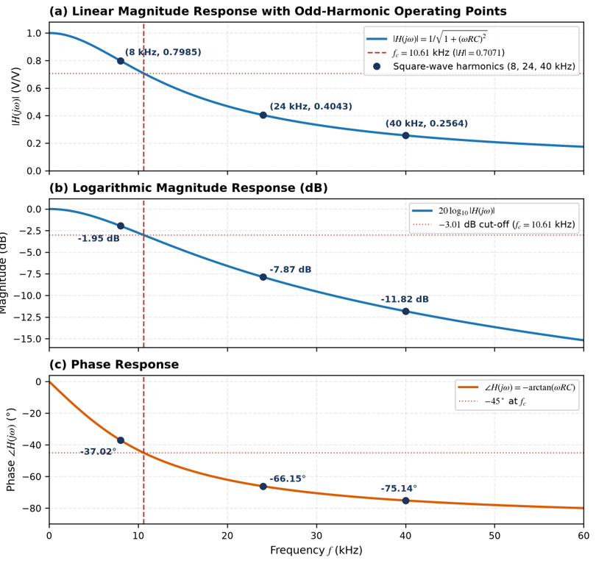
Figure 10. Theoretical RC frequency response (0–60 kHz) showing cut-off f_{c} = 10.61 kHz and harmonic operating points at 8, 24, and 40 kHz: (a) linear magnitude, (b) decibel gain, and (c) phase.
C(c) Filtered Output Harmonic Magnitudes (15 V_{pp} Input)
Method (Equation 5): |V_{o,n}| = b_{n} × |H(jnω₀)|, then |V_{o,n}|(dBV) = 20 log₁₀|V_{o,n}|
b_{n} values are taken from C(a) and |H(jnω₀)| values from C(b).
8 kHz (n = 1)
Output: $\left|V_{o,1}\right|\text{ = 9.55 × 0.7985 = 7.63 V}$
Level: $\left|V_{o,1}\right|\text{ (dBV) = 20 }{\text{log}}_{\text{10}}\left(\text{7.63}\right)\text{ = 17.65 }\text{dBV}$
24 kHz (n = 3)
Output: $\left|V_{o,3}\right|\text{ = 3.18 × 0.4043 = 1.29 V}$
Level: $\left|V_{o,3}\right|\text{ (dBV) = 20 }{\text{log}}_{\text{10}}\left(\text{1.29}\right)\text{ = 2.19 }\text{dBV}$
40 kHz (n = 5)
Output: $\left|V_{o,5}\right|\text{ = 1.91 × 0.2564 = 0.49 V}$
Level: $\left|V_{o,5}\right|\text{ (dBV) = 20 }{\text{log}}_{\text{10}}\left(\text{0.49}\right)\text{ = -6.19 }\text{dBV}$
Table 6. Post-Lab Section C summary of theoretical input and output harmonics for the 15 V_{pp}, 8 kHz square wave (peak dBV convention).
Harmonic | Frequency (Hz) | ω (rad/s) | Magnitude | Input (V) | Input (dBV) | Output (V) | Output (dBV)
Fundamental | 8,000 | 50,265.48 | 0.7985 | 9.55 | 19.60 | 7.63 | 17.65
Even Harmonics | 16,000 / 32,000 | 100,530.96 / 201,061.93 | 0.5535 / 0.3160 | 0.00 | — | 0.00 | —
3rd Harmonic | 24,000 | 150,796.45 | 0.4043 | 3.18 | 10.06 | 1.29 | 2.19
5th Harmonic | 40,000 | 251,327.41 | 0.2564 | 1.91 | 5.62 | 0.49 | −6.19
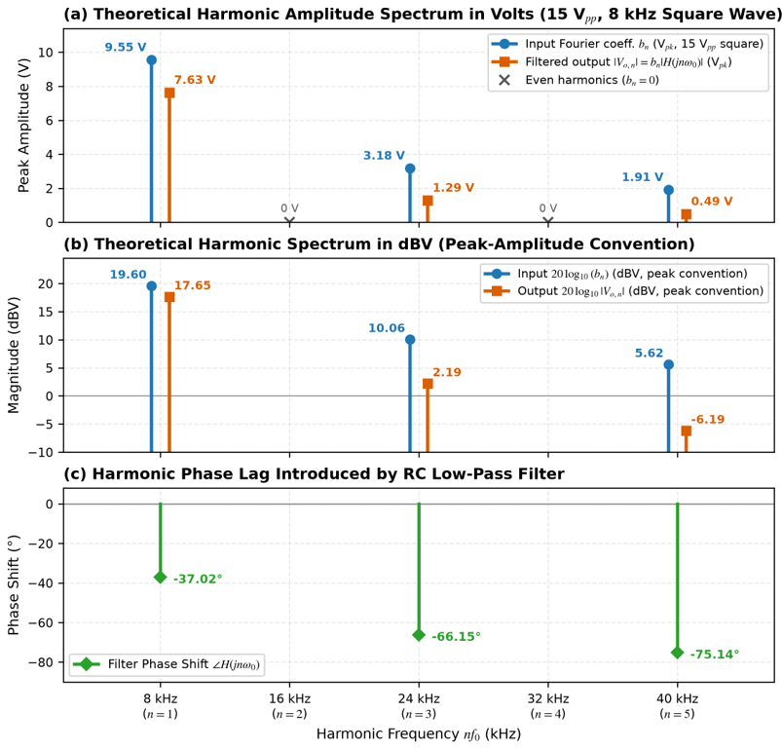
Figure 11. Theoretical discrete input and output harmonic spectra for the 15 V_{pp}, 8 kHz square wave: (a) peak Volts, (b) peak-convention dBV, and (c) phase lag.
C(d) Expected Time-Domain Output Waveform
Given: A = 7.50 V, T₀ = 125 µs (half-period T₀/2 = 62.5 µs), τ = RC = 15 µs
Calculation – steady-state peak capacitor voltage (Equation 5):
Peak output: $V_{\text{o,peak}}\text{ = 7.50 tanh}\left[\frac{\text{125 µs}}{\text{4 × 15 µs}}\right]\text{ = 7.50 }\text{tanh(}\text{2.0833) = ±7.27 V}$
Peak-to-peak: $V_{\text{o,pp}}\text{ = 14.54 }{\text{V}}_{\text{pp}}$
Because higher odd harmonics (24 and 40 kHz) are strongly attenuated and phase-delayed relative to the 8 kHz fundamental, sharp vertical jumps are removed and the output becomes a smooth exponential charging/discharging waveform (Figure 12).
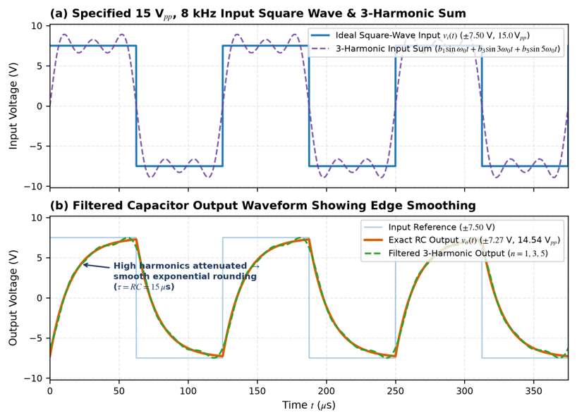
Figure 12. Scaled theoretical time-domain waveforms (15 V_{pp}, 8 kHz): (a) input square wave and 3-harmonic synthesis; (b) steady-state capacitor output (±7.27 V, 14.54 V_{pp}).

3.6 Experimental Square-Wave Oscilloscope Measurements (Time Domain & FFT)
For the oscilloscope (Keysight DSOX4024G) (Figure A4 in the Appendix, Table 7), Channel 1 measured 20.1 Vpp (flat plateau of Ampl(1) = 15.1 V) at 8.0000 kHz, instead of the nominal 15 Vpp. Channel 2 output exhibited an “exponentially rounded” capacitor response of 14.9 Vpp (Ampl(2) = 14.2 V), which agrees with the LP corner smoothing observed in the previous section.
Table 7. Experimental oscilloscope measurements for the 8 kHz square wave.
Quantity | Scope Readout | Specified | Measured | Observation
Input Peak-to-Peak | CH1 Pk-Pk | 15.0 Vpp | 20.1 Vpp | Higher than specified
Input Plateau | CH1 Amplitude | 15.0 V | 15.1 V | Flat swing excluding spikes
Output Peak-to-Peak | CH2 Pk-Pk | 14.54 Vpp | 14.9 Vpp | Rounded exponential curve
Output Amplitude | CH2 Amplitude | — | 14.2 V | Capacitor swing between transitions
Frequency | CH1 / CH2 Frequency | 8.00 kHz | 8.0000 / 7.9949 kHz | Within 0.06% of specified
FFT Peak Locations | FFT Cursor X1 | 8, 24, 40 kHz | 8.0, 23.9, 40.0 kHz | Odd harmonics present
The output spectrum FFT(CH2) in the oscilloscope is shown in Figure A5 (Appendix) with the cursor X1 set at 8.0, 23.9 (nearest 954 Hz bin to 24 kHz) and 40.0 kHz, to confirm the presence of odd harmonics and the absence of even harmonics (16, 32 kHz). No paired FFT harmonic amplitude and gain measurements could be taken, however, due to the FFT(CH2) captures having horizontal cursor Y1 set at −2.50 dBV, and no corresponding FFT(CH1) peak cursor readings.

3.7 Result Sheet Section C: Predicted Harmonic Response for 20.1 V_{pp} Input (Table C)
Basis: Paired FFT peak cursor readings were unavailable, so the Table C levels below are predicted (not measured) values, calculated from the observed 20.1 V_{pp} input and the theoretical |H(jnω₀)|, using peak-convention dBV.
Step 1 – Observed peak amplitude: A_{obs} = 20.1 / 2 = 10.05 V
Step 2 – Predicted input coefficients (Equation 4): b_{n,pred} = 4A_{obs} / (nπ) = 4(10.05) / (nπ) = 40.2 / (nπ) V
Step 3 – Evaluate each odd harmonic: input b_{n,pred} → output |V_{o,n,pred}| = b_{n,pred} × |H(jnω₀)| → gain G_{n} = |V_{o,n}|(dBV) − b_{n}(dBV)
At f₁ = 8 kHz (n = 1):
Input: $b_{\text{1,pred}} = \frac{\text{40.2}}{π}\text{ = 12.80 V → 22.14 dBV}$
Output: $\left|V_{\text{o,1,pred}}\right|\text{ = 12.80(0.7985) = 10.22 V → 20.19 }\text{dBV}$
Gain: $G_{\text{1}}\text{ = 20.19 - 22.14 = -1.95 dB}$
At f₃ = 24 kHz (n = 3):
Input: $b_{\text{3,pred}} = \frac{\text{40.2}}{3π}\text{ = 4.27 V → 12.60 dBV}$
Output: $\left|V_{\text{o,3,pred}}\right|\text{ = 4.27(0.4043) = 1.72 V → 4.72 }\text{dBV}$
Gain: $G_{\text{3}}\text{ = 4.72 - 12.60 = -7.87 dB}$
At f₅ = 40 kHz (n = 5):
Input: $b_{\text{5,pred}} = \frac{\text{40.2}}{5π}\text{ = 2.56 V → 8.17 dBV}$
Output: $\left|V_{\text{o,5,pred}}\right|\text{ = 2.56(0.2564) = 0.66 V → -3.65 }\text{dBV}$
Gain: $G_{\text{5}}\text{ = -3.65 - 8.17 = -11.82 dB}$
Table 8 (Table C). Predicted square-wave harmonic response for the observed 20.1 V_{pp} input (peak-amplitude dBV — predicted, not measured).
Spectrum Characteristic | Frequency | Predicted Output | Predicted Input | Predicted Gain | Theoretical Response
Fundamental | 8 kHz | 20.19 dBV | 22.14 dBV | −1.95 dB | −1.95 dB
3rd Harmonic | 24 kHz | 4.72 dBV | 12.60 dBV | −7.87 dB | −7.87 dB
5th Harmonic | 40 kHz | −3.65 dBV | 8.17 dBV | −11.82 dB | −11.82 dB
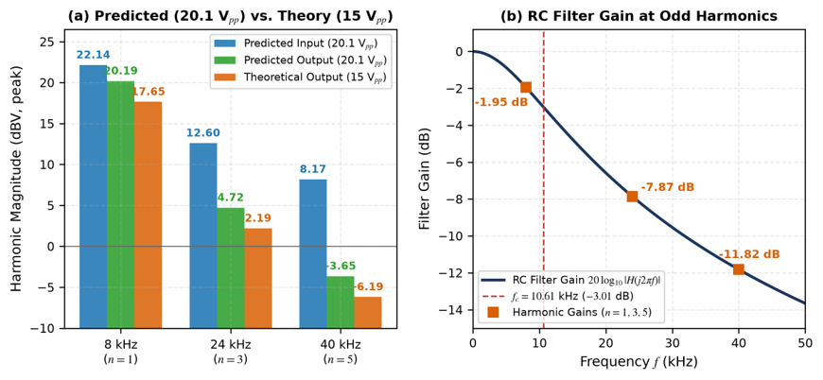
Figure 13. (a) Predicted harmonic magnitudes (20.1 V_{pp} basis) vs. 15 V_{pp} theoretical outputs; (b) harmonic gains along the RC Bode curve.

4. Discussion

4.1 Sinusoidal Frequency Response
Experimental results were found to be in good agreement with the theoretical frequency response of RC low pass filter. The deviations of measured gains from the theoretical gains were about 0.19 dB, 0.05 dB and 0.47 dB at 1 kHz, 10 kHz and 40 kHz, respectively.
The measured gain was −2.81 dB at 10 kHz, and the −3 dB cutoff point was 10.61 kHz, a value very close to the measured value. This facilitates the expected low pass filtering effect, that is, that higher frequencies are reduced more than lower ones.
The time domain waveforms also showed a decrease in output amplitude and a steady increase in phase delay with increasing frequency, which is similar to the frequency domain results. The slight differences from the theoretical values can be caused by the tolerances of the components as well as fluctuations in the input voltage and the measurement inaccuracies of the oscilloscope.
In general, both the amplitude and phase response of the RC circuit in the time and frequency domain were observed to agree with the predictions.

4.2 Low-Pass Filtering and Square-Wave Edge Smoothing
Capacitor reactance XC = 1/(2πfC) falls from 1.99 kΩ at 8 kHz to 663 Ω at 24 kHz and 398 Ω at 40 kHz, so the RC circuit (fc = 10.61 kHz) passes the 8 kHz fundamental with small attenuation (−1.95 dB) while strongly attenuating the 24 kHz (−7.87 dB) and 40 kHz (−11.82 dB) harmonics. High frequency odd harmonics are needed for sharp vertical square wave transitions, which then produce rounded corners (Figure A4) with exponential charging and discharging curves that have a time constant of 15 µs (T0/2 = 62.5 µs = 4.17τ), which is the same as the smooth 14.9 Vpp Channel 2.

4.3 Input Voltage Discrepancy (15 V_{pp} vs. 20.1 V_{pp})
Specified 15 Vpp but Channel 1 actually measured Pk-Pk(1) = 20.1 Vpp and the flat plateau measured Ampl(1) = 15.1 V. The difference was caused by driving a high impedance (1 MΩ) load from a 50 Ω function generator, and assuming High-Z termination mode for the input, yet the fast-edge ringing/overshoot at the jumpers was caused by the input load inductance (ECU, 2026a). Notably, applying Equation (5) to the 15.1 V plateau gives 15.1 tanh(62.5/30) = 14.64 Vpp, closely matching the measured 14.9 Vpp (Ampl(2) = 14.2 V) output.

4.4 Separation of Data Sets and Experimental Limitations
• Data separation: LTI harmonic gains (−1.95, −7.87, −11.82 dB) are amplitude independent, and are kept strictly separate from theoretical and predicted Table C values (15 Vpp, 20.1 Vpp) and from measured oscilloscope values (Tables 5–8).
• FFT cursor & resolution limits: Screenshots only made of FFT(CH2) while Y1 was set to −2.50 dBV and coarse bin spacing was set to 954 Hz (placing 24 kHz at 23.9 kHz). Peak tracking cursors on both FFT(CH1) and FFT(CH2) should be possible for narrower spans of frequencies in future measurements.
• Component tolerances & applications: The tolerances for R and C are measured ±5%–10%, which will result in a slight variation of fc. From a practical point of view, this RC harmonic attenuation is applied in PWM digital-to-analogue smoothing and clock EMI reduction (ECU, 2026b).

5. Conclusion
First-order series RC low-pass filter (R = 1.5 kΩ, C = 0.01 μF, τ = 15 μs, fc = 10.61 kHz): Sinusoidal and square-wave inputs were applied to this low-pass filter; theory and oscilloscope measurements were compared.
For 15 Vpp sinusoids at 1, 10 and 40 kHz, measured gains (−0.23, −2.81, −11.35 dB) matched theory (−0.04, −2.76, −11.82 dB) within 0.5 dB, and measured phase shifts (−6.65°, −42.30°, −73.71°) were close to theoretical values (−5.39°, −43.30°, −75.14°). The gain at 10 kHz was −2.81 dB, revealing that the cut-off frequency is close to 10.61 kHz.
The 8 kHz square wave with a duty cycle of 50% had only odd harmonics. The fundamental was slightly reduced in level (−1.95 dB) and the harmonics at 24-kHz and 40-kHz were reduced in levels (−7.87 dB and −11.82 dB). These two parts of the experiment are connected by the 40 kHz harmonic with the same theoretical attenuation as the 40 kHz sinusoid. The measured output (20.1 Vpp input, 14.9 Vpp exponential output) was passed through an FFT to reveal odd harmonic peaks at around 8, 24 and 40 kHz.
In general, frequencies below are not greatly affected by the attenuation or phase shift, and frequencies higher in the frequency range are increasingly affected by the attenuation and delay. This is applied to every Fourier component accounting for the elimination of sharp edges of the square wave. The small differences were due to component tolerances, input variations, generator loading and oscilloscope resolution, and are similar to the LTI concepts employed in PWM smoothing and signal conditioning.

References
Edith Cowan University. (2026a). Laboratory 2: Frequency response of systems [Assignment]. ENS6160 Signals and Systems, Canvas. https://courses.ecu.edu.au/courses/57801/assignments/354833
Edith Cowan University. (2026b). Signal and system slides [Lecture slides, PDF]. ENS6160 Signals and Systems, Canvas. https://courses.ecu.edu.au/courses/57801/assignments/354833
Edith Cowan University. (2026d). Tute Q6 [Tutorial worksheet, PDF]. ENS6160 Signals and Systems, Canvas. https://courses.ecu.edu.au/courses/57801/assignments/354833
Google. (2019). Google Colaboratory. Google.Com. https://colab.research.google.com/

Appendix
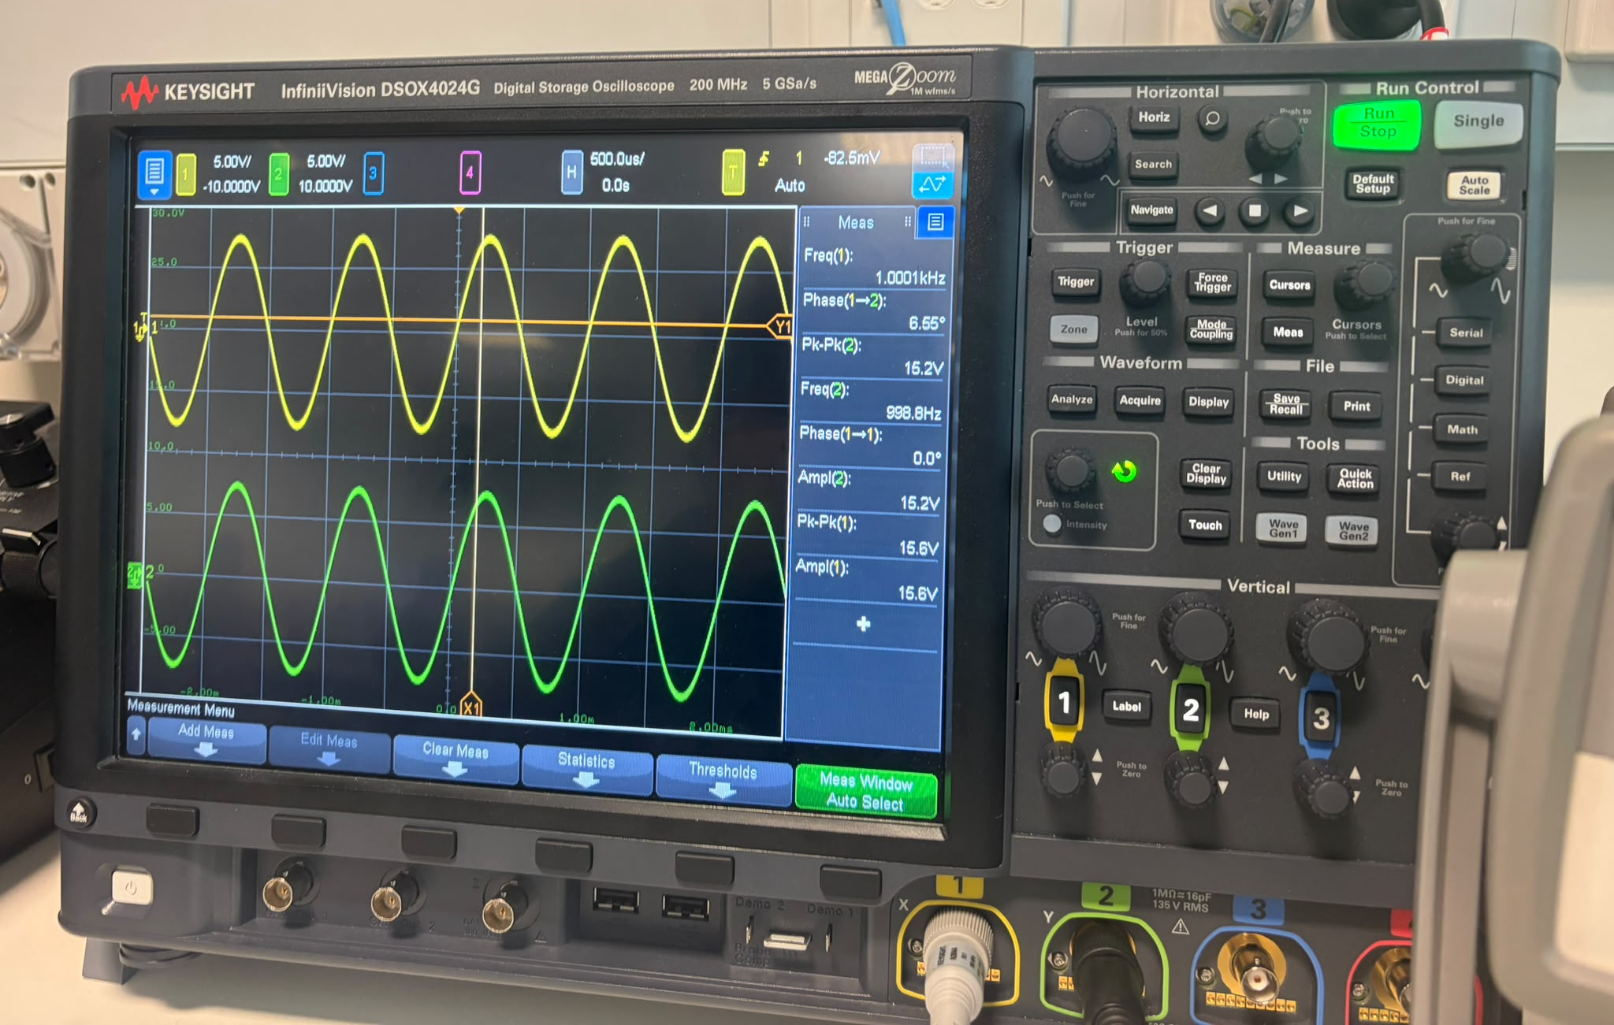
Figure A1. Experimental input and output sinusoidal waveforms at 1 kHz.
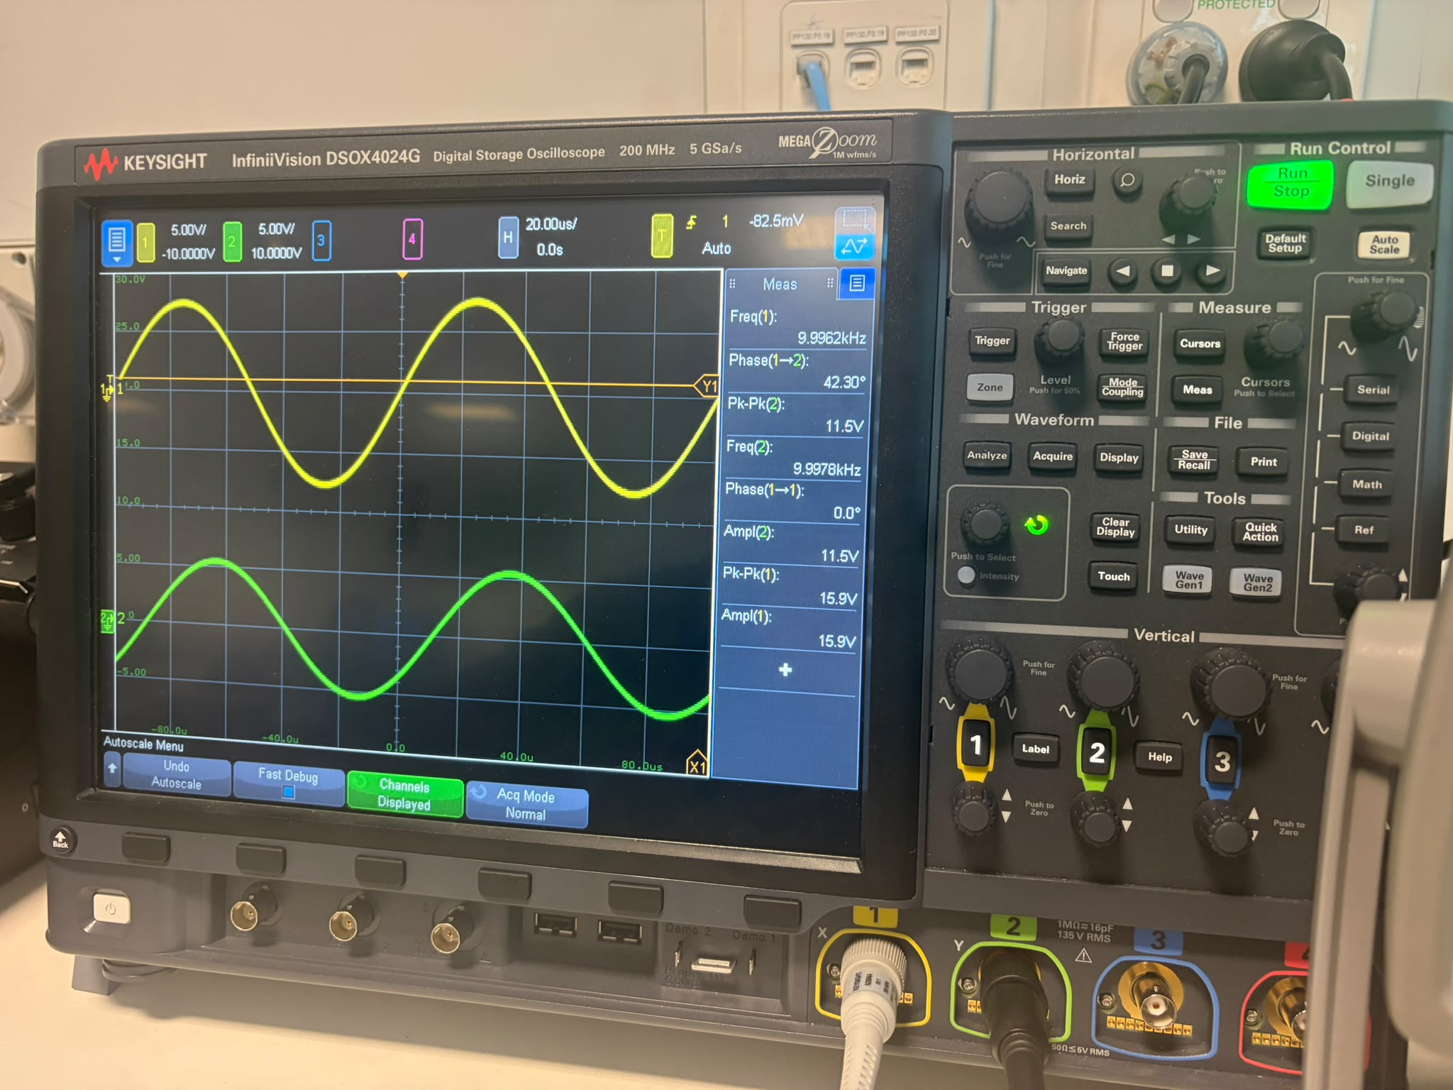
Figure A2. Experimental input and output sinusoidal waveforms at 10 kHz.
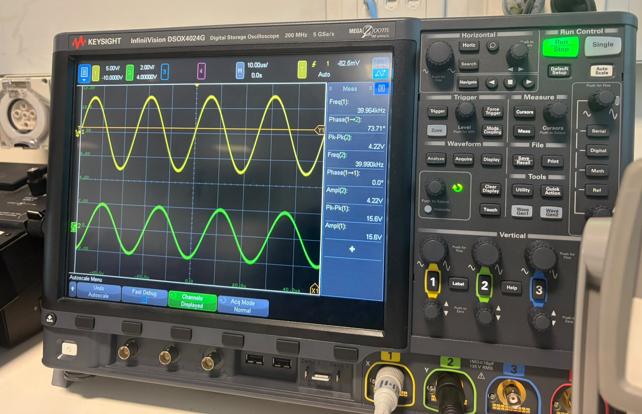
Figure A3. Experimental input and output sinusoidal waveforms at 40 kHz.
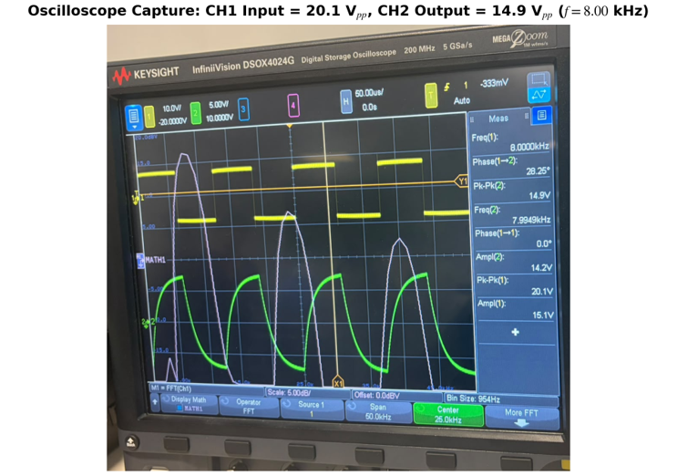
Figure A4. Experimental oscilloscope capture of the 8.00 kHz square wave: CH1 input = 20.1 Vpp (Ampl = 15.1 V) and smoothed CH2 output = 14.9 Vpp (Ampl = 14.2 V).
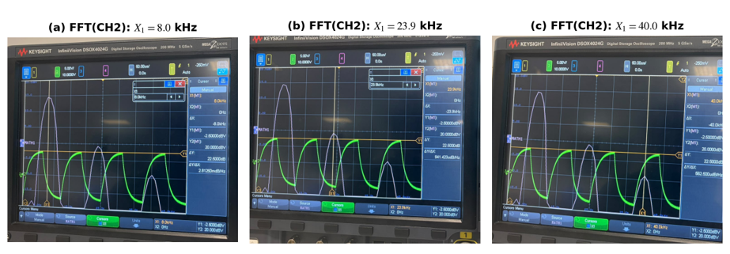
Figure A5. Experimental FFT(CH2) captures at (a) 8.0 kHz, (b) 23.9 kHz (~24 kHz), and (c) 40.0 kHz (manual Y1 cursor uncoupled at −2.50 dBV).

Acknowledgement of AI Use
Generative AI tools—Claude (Anthropic)—were used solely to assist with the structuring and formatting of this document. All written content, data, analysis, and interpretations are entirely the original work of the author(s) and have been independently verified for accuracy.
ChatGPT was utilised as a supplementary tool to provide guidance on graph generation during the preparation of this report. All experimental procedures, measurements and results were independently conducted and verified.

